**CREATE A DATABASE IN CLOUDANT DB**

|  |  |
| --- | --- |
|  |  |
| Team ID | PNT2022TMID50776 |
| Project Name | IOT based safety gadget for  child safety monitoring and notification |
| Maximum Marks | 4 Marks |
|  |  |

Create A Database In Cloudant DB

Aim: To create a database in Cloudant DB to store location data.

Steps followed:

* Logged in to IBM Cloud account
* 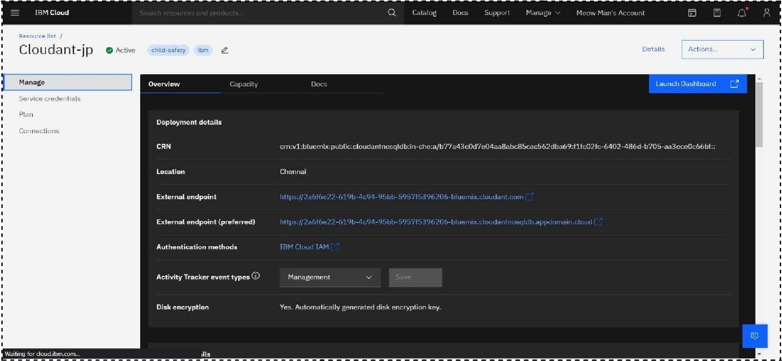Navigated to `./resources`
* Clicked on the “Create Resource +” button
* Searched for “Cloudant”
* Chose the “Lite Version” and clicked on “Create”

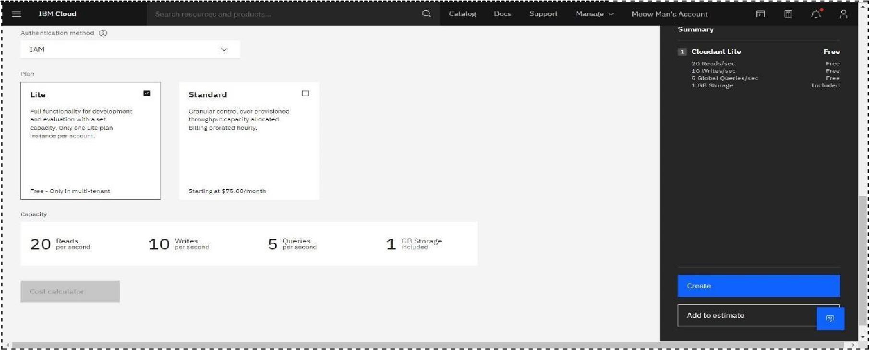

* The Cloudant database resource was created successfully

* Clicked on Launch Dashboard

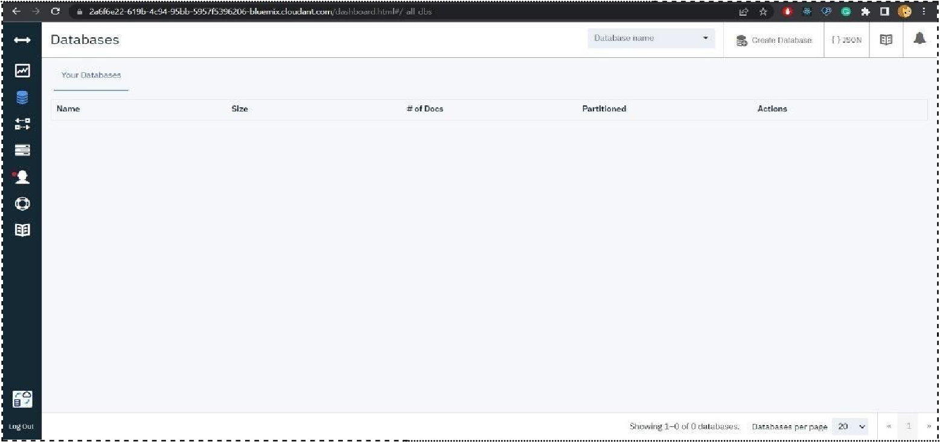

* Clicked on “Create Database”. Entered “meowman” as the database name and the “Non-partitioned” option

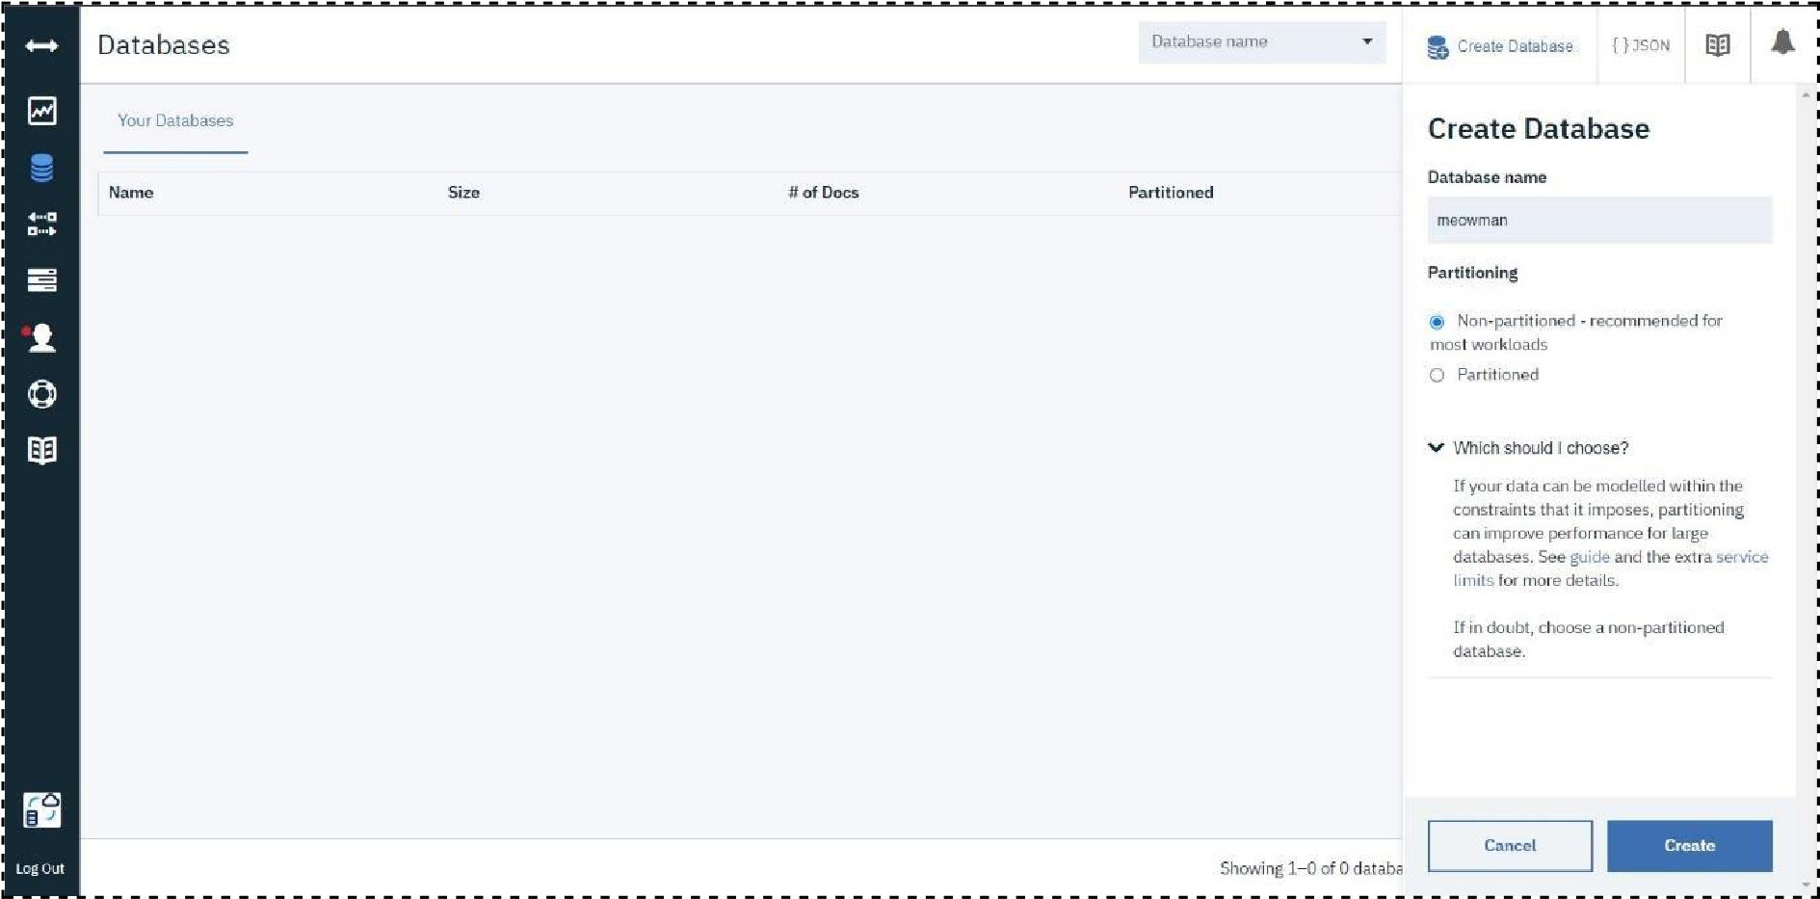

* The database “meowman” was created successfully

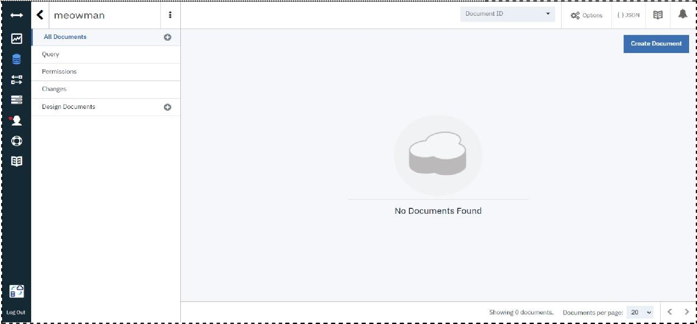

Result:

A database to store the location data was created successfully on Cloudant DB